PENGAJUAN DANA INSPEKSI

1. BIAYA SERVICE XENIA DK 1737 CU DAN LEXUS NX 300 HITAM DK 1206 ADJ

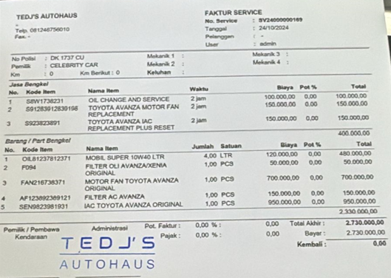

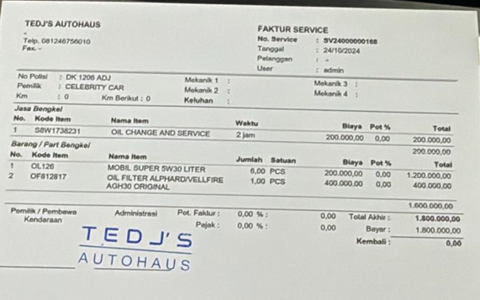

1. REMBES COVER BAN SEREP RUBICON SHORT B 1780 BJT

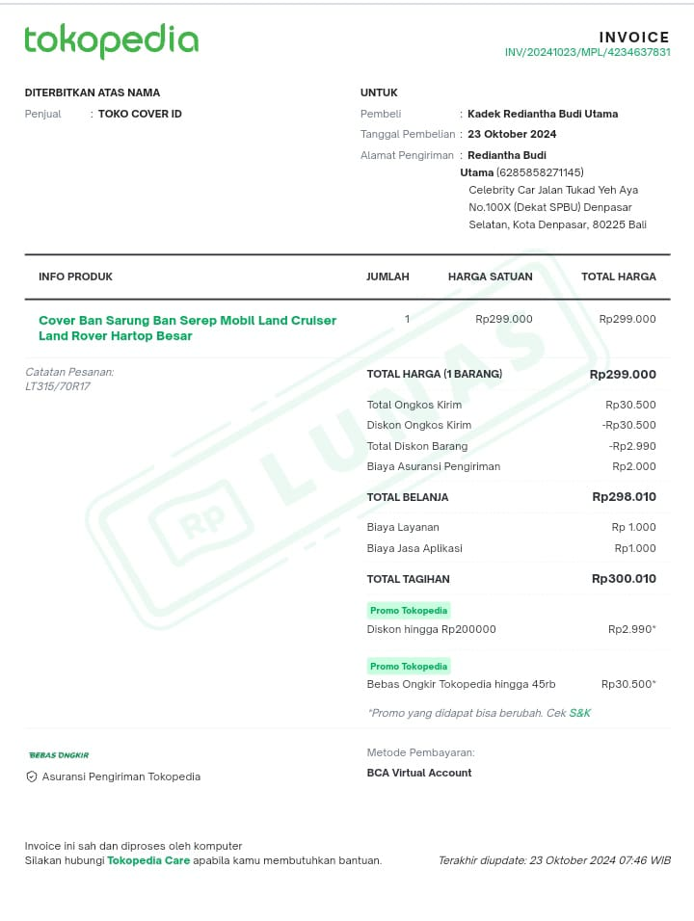

1. BIAYA CAT BMW X5 D 1420 HA

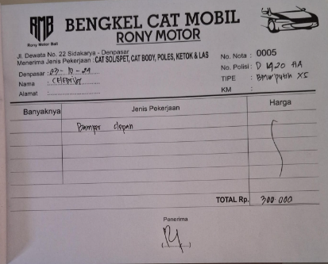

1. BELI SENTER

